

**SMART BLIND STICK FOR BLIND PEOPLE (ROBOTICS PROJECT)**

**CIRCTUIT DIAGRAM**

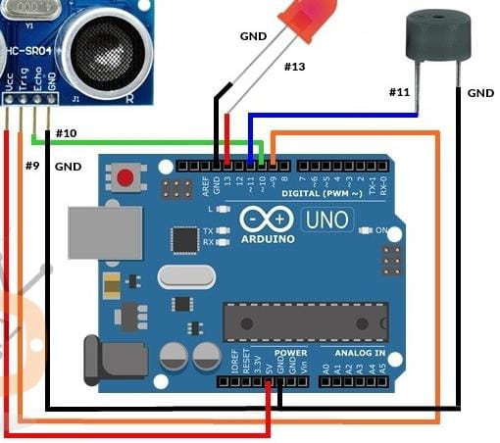

**CODING**

**// defines pins numbers**

**const int trigPin = 9;**

**const int echoPin = 10;**

**const int buzzer = 11;**

**const int ledPin = 13;**

**// defines variables**

**long duration;**

**int distance;**

**int safetyDistance;**

**void setup() {**

**pinMode(trigPin, OUTPUT); // Sets the trigPin as an Output**

**pinMode(echoPin, INPUT); // Sets the echoPin as an Input**

**pinMode(buzzer, OUTPUT);**

**pinMode(ledPin, OUTPUT);**

**Serial.begin(9600); // Starts the serial communication**

**}**

**void loop() {**

**// Clears the trigPin**

**digitalWrite(trigPin, LOW);**

**delayMicroseconds(2);**

**// Sets the trigPin on HIGH state for 10 micro seconds**

**digitalWrite(trigPin, HIGH);**

**delayMicroseconds(10);**

**digitalWrite(trigPin, LOW);**

**// Reads the echoPin, returns the sound wave travel time in microseconds**

**duration = pulseIn(echoPin, HIGH);**

**// Calculating the distance**

**distance= duration*0.034/2;**

**safetyDistance = distance;**

**if (safetyDistance <= 5){**

**digitalWrite(buzzer, HIGH);**

**digitalWrite(ledPin, HIGH);**

**}**

**else{**

**digitalWrite(buzzer, LOW);**

**digitalWrite(ledPin, LOW);**

**}**

**// Prints the distance on the Serial Monitor**

**Serial.print("Distance: ");**

**Serial.println(distance);**

**}**